**ATOM CON ANGULAR 4**

PAQUETE ATOM-TYPESCRIPT:

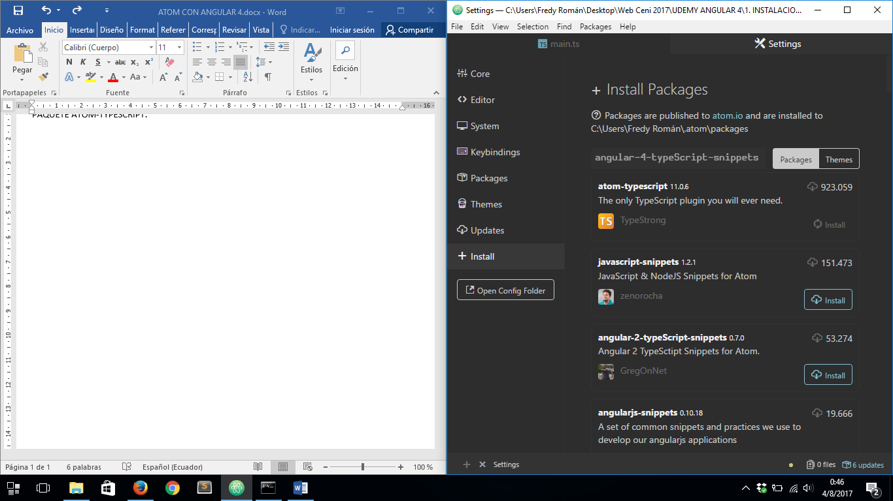

ANGULAR-2-TYPESCRIPT-SNIPPETS:

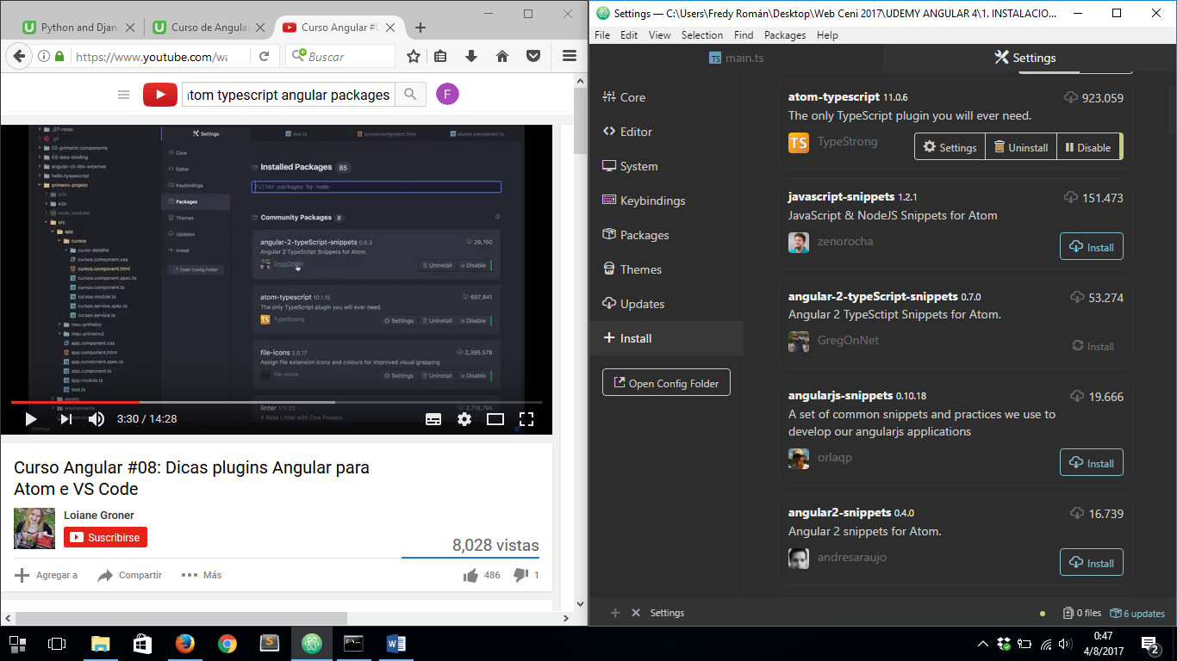

LINTER:

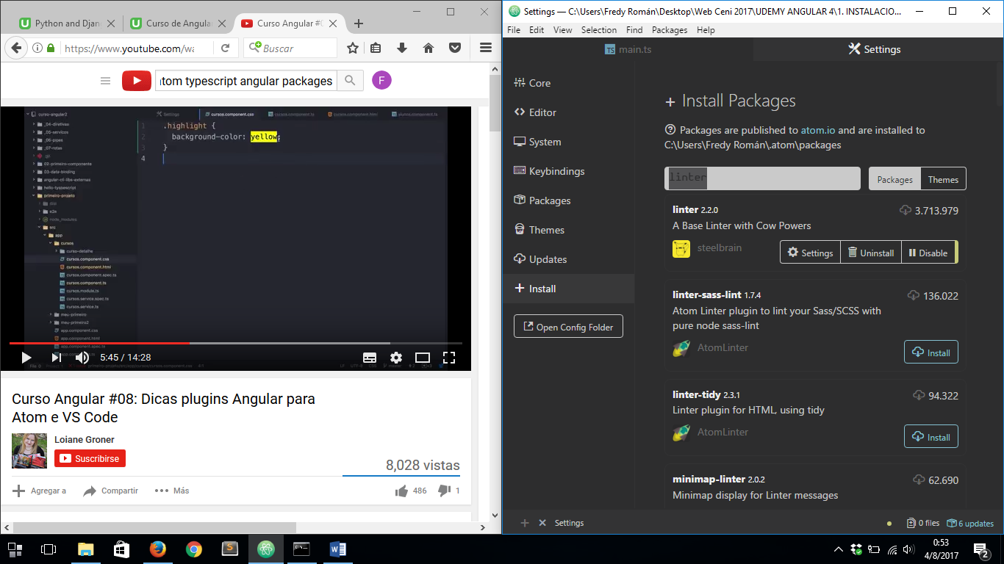

OPEN RECENT:

